# RESEARCH STRATEGY – project 3 - biomarkers of human epileptogenesis after traumatic brain injury

# 1. SIGNIFICANCE

Development of prevention and disease modifying treatments for epilepsy requires understanding epileptogenic mechanisms, the timing of epileptogenesis, and biomarkers that accurately indicate the disease process. PTE is common, occurring in 15-55% of patients with severe TBI2,32,47 but the latency from injury to the onset of recurrent seizures is short, usually less than 2 years. PTE is a significant public health burden, comprising 5% of patients referred for evaluation of drug resistant epilepsy. The literature is replete with putative predictors of PTE2,13,31,47, including markers of severity of injury such as intraparenchymal hemorrhage, skull fracture, and penetrating injury. PTE is associated with long term hippocampal disconnection, atrophy, cell loss and localized neocortical gliosis4,40,42,56. However, putative accurate biomarkers of epileptogenesis have not been validated in humans during the ‘latent’ period45 and prospective studies of anti-seizure drugs have failed to modify epileptogenesis after severe TBI50 or the resultant structural and functional deficits34.

It is noteworthy that there have been no prospective comprehensive studies of the epileptogenic process starting immediately after human TBI51, unlike recent animal studies on PTE. Recent studies of cEEG in moderate-severe TBI demonstrate a high incidence of early seizures (25%) and interictal epileptiform activity (45-60%)53,55,57,62. The epileptiform activity begins within the first week after moderate-severe TBI, and is associated with important physiological changes in excitatory neurotransmitters52,54,57 and brain metabolism55,57. The rate of early seizures is higher, over 60%, when depth EEG is used57,62. These EEG findings indicate early onset of epileptogenesis within the first week after TBI, and suggest that EEG is an important and specific biomarker that can be used to identify those patients at high risk for PTE long before epilepsy is established. Human TBI is amendable to comprehensive study in the ICU using sophisticated disease biology research techniques including phenotypic MRI imaging, cEEG and depth EEG, acute biomarker tracking and long term cognitive follow up37,56,65,67,68 .

**The EpiBioS4Rx Scientific Premise is Epileptogenesis after TBI can be prevented with specific treatments; the identification of relevant biomarkers and performance or rigorous preclinical trials will permit the future design and performance of economically feasible full-scale clinical trials of antiepileptogenic therapies.**

We have crafted the animal projects and human project to study a specific TBI injury type, hemorrhagic contusional injury to temporal lobe ± frontal lobe, based on our preliminary data in both humans and animals. We hypothesize that post-traumatic epileptogenesis can be identified by specific biomarkers including electroencephalography (EEG), MRI, and blood biomarkers. Table 1 outlines the biomarkers that we plan to study. These biomarkers are derived from our preliminary animal data in *Projects 1 and 2,* our preliminary human studies, and data from the literature. We outline how these biomarkers interrelate to all of our projects and lead towards identifying mechanisms of epileptogenesis and potential novel therapies.

|  |  |  |  |  |
| --- | --- | --- | --- | --- |
| Biomarker | Mechanism | Expected change | Antiepileptogenesis (AEG) Treatment in Project 2 | Reference |
| EEG: pHFO, rHFOSs, seizures | Clustering of Synchronized depolarization | Present | Multiple drugs: Z944, Sodium Selenate; Deferiprone; Kineret +- VX765 | 1,7, 8, 9, 29,49, 57 |
| Tau (total) | Protein Phosphatase 2 | Increase in PTE 150-200% | Sodium Selenate | 33, 35, 48 |
| IL1β | CNS inflammation | Increase in PTE 100% | Kineret +- VX765, miRNAs | 61 |
| TBI biomarkers  GFAP, S100B, MBP, GFAP | CNS injury | Increased in PTE 50% above TBI background | Multiple drugs | Project 1 Preliminary gene activation data |
| miRNA  such as 106b-5p | Inflammation | Increase in PTE 50% above TBI background | Antiinflammatory Drugs | 61 |
| Hippocampal /Thalamic structural functional changes | Network plasticity | Altered connectivity as compared with TBI background | Multiple | 5, 17, 22, 23, 28, 42 |

**Table 1**: Proposed biomarkers to be studied in Projects 1, 2, and 3 to determine optimal patient cohort and candidate antiepileptogenic agents.

We plan to explore these biomarkers after human TBI with a focus on demonstrating that patients with PTE will have one or more biomarkers indicating early epileptogenesis using a rigorous experimental design for robust and unbiased results. Predictions for these biomarkers are as follows: 1) EEG biomarkers will be early seizures, pHFO and rHFOSs1,7,54,57.2) MRI imaging will show enhanced structural connectivity between hippocampal and thalamic structures5,22,23,28, enhanced functional connectivity within the limbic system in epilepsy22, functional connectivity deficits in cortical-to-hippocampal pathways42, and functional hippocampal connectivity changes40. Graph theory fMRI studies showing increased path length, lowered clustering coefficient and changes in small world connectivity have been reported in epilepsy17. 3) Blood biomarkers will be increased in those patients with TBI, for example p-tau33,35. A number of blood biomarkers of epileptogenesis have been demonstrated in animals and humans and may be elevated in common with TBI, such as GFAP, S100B, and IL6 and micro-RNA 106b-5p61. This collection of biomarkers will be studied in projects 1 and 2 and those results will inform the significance of these biomarkers in the human cohort after TBI.

# 2. INNOVATION

EpiBioS4Rx-Project 3 offers the following innovation elements:

Innovative Hypotheses:The principal hypothesis is that we can create a personalized medicine approach to the prevention of PTE through defining TBI patients at high risk of PTE based on ICU EEG, imaging, and serum biomarkers. The secondary hypothesis is that epileptogenesis can be diagnosed during the latent period, prior to the establishment of PTE, creating a potential window for preventative or disease modifying therapies.

Innovative Collaborations with NIH Funded TBI Studies and Epilepsy Trialists**:** The proposed project is one of the first of its kind to team up leaders in TBI research with leaders of epilepsy research to study the development of one of the more common causes of acquired epilepsy, TBI. Three existing studies including CENTER-TBI, ADAPT, and TRACK-TBI have been NIH funded, have formal SOPs, and are actively collecting and sharing TBI data. Within those centers, we have created a network of ICU EEG Monitoring TBI Centers with expertise in high resolution, sophisticated EEG monitoring and brain imaging, both in adults and children that will be necessary for an eventual clinical trial. We plan a priori for data synthesis across three large-scale studies plus our comprehensive data set of 300 severe TBI patients in order to select the ‘at-risk’ cohort criteria. We have a highly experienced team of experts in TBI, ICU EEG monitoring and PTE including Drs. Paul Vespa, Jerome Engel, Lawrence Hirsch, Jan Claassen, Mike Bell, Jed Hartings, Nicholas Abend, and David Menon to assist us in this prospective study and a DSMB consisting of Drs French, Perucca, Jette, Bleck, Kwan, and Twyman who will advise us on both human and preclinical studies. In the Public Engagement core, we formed a consortium of consumer groups, health organizations, scientific (professional) societies, and investigators to allow the public to be involved in the design of antiepileptogenic clinical trials, including research strategies, successful enrollment, and retention. To this goal, the will also help translate our results into clinical trial design.

Innovative Longitudinal Study of Epileptogenesis: We propose to study prospectively patients from the onset of TBI through the first two years after TBI. Current TBI observational studies have not followed patients long enough to determine the occurrence of epilepsy and have not carried out the objective measures needed to identify and characterize PTE and the epileptogenic process. By the end of 2 years, 75% of patients who develop PTE will do so. Results from Project 3 will inform the translational importance of results from *Projects 1 and 2,* and provide foundations for mechanisms and timing of epileptogenesis.

# 3. Approach

# 3.1. BACKGROUND / PRELIMINARY DATA

3.1.1. (SA 1): The incidence of PTE is high after moderate-severe TBI: In a pilot study of PTE in a well characterized, prospectively studied (from 2001-), patients with moderate-severe TBI (GCS 3-12) (n=46) at UCLA, the development of PTE occurred in 21/46 (46%) of patients, with 48% of those having early seizures. Patients had ICU cEEG, acute ICU prospective data collection, acute and 6 month structural MRI, and cognitive outcome studies at 6-12 months. The standardized Ottoman PTE long term telephone questionnaire44 was conducted at 2-10 years after TBI in September 2013. Multivariate analysis revealed that the independent risk factors for the development of PTE were acute temporal lobe injury (OR 4.6, p< 0.001) and surgery (2.09, p < 0.001) but not injury severity (GCS). Patients with PTE have worse long term functional outcome (GOSe at 2-12 yrs < 0.01).

**PTE SUMMARY TABLE (n=46)**

|  |  |  |  |  |  |
| --- | --- | --- | --- | --- | --- |
|  | No PTE | PTE |  |  |  |
|  | n = 25 | n = 21 | Odds Ratio | 95% CI | P-Value |
| *Demographics* |  |  |  |  |  |
| Age | 33.64 ± 12.67 | 40.76 ± 21.22 | -- | -- | 0.393 |
| GCS | 5.96 ± 3.55 | 4.70 ± 3.01 | -- | -- | 0.09 |
| *Injury Characteristics* |  |  |  |  |  |
| Surgery | 14 (56.0%) | 15 (71.4%) | 1.92 | 0.56 - 7.08 | 0.311 |
| Temporal Lobe Injury | 9 (36.0%) | 18 (85.7%) | 9.76 | 2.45 - 53.13 | < 0.001* |
| *Outcome Measures* |  |  |  |  |  |
| GOSe (6 Month) | 5.39 ± 1.62 | 4.06 ± 1.66 | -- | -- | 0.006* |
| GOSe (2-10 Year) | 6.64 ± 1.29 | 4.81 ± 2.06 | -- | -- | 0.003* |

**Table 2:** Summary of pilot study: GCS – Glasgow coma score, GOSe: Glasgow outcome score extended at 6 month and long term between 2-12 years. Seizure positive includes early seizures (< 7 days) and delayed seizures at any time during follow up.

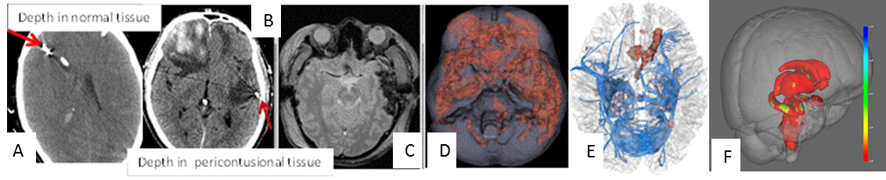

**Figure 1.** Methods demonstrating feasibility of SA1, SA2: Image guided placement of depth EEG (frontal normal tissue (A), pericontusional temporal lobe (B) (SA2). Lesion appearance on MRI GRE (C). Lesion load map (D) showing areas of injury (red) in the UCLA pilot group (n=46). Regional tractography of fiber tracts that are disrupted acutely after TB (E. In (F), we demonstrate hippocampal atrophy in PTE + cohort (n=2)1 vs NonPTE BI cohort (n=21).

3.1.2. (SA 1): Early post-traumatic seizures occur very frequently after moderate-severe TBI when continuous EEG monitoring is used: We reported that 23% of severe TBI patients that are monitored by cEEG show nonconvulsive seizure activity and over 40% show interictal epileptiform activity in the first weeks after injury15,54,56,57. In depth EEG recordings from Columbia and UCLA, 60%-70% of TBI patients on depth EEG57,62 (Appendix 2).

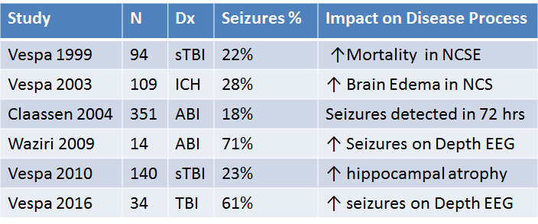

**Table 3:** Summary of recent literature on cEEG monitoring in severe TBI GCS 3-8; ABI: acute brain injuries including nontraumatic intracerebral hemorrhage. There is a high incidence of acute seizures in the ICU.

3.1.3. (SA 1): Detection of pHFOs on depth EEG in severe TBI. An example case of recording pHFO on depth EEG recording in acute human TBI (Figure 2), Brief bursts consisting of 10-14 Hz EEG spikes, which resemble rHFOSs found in PTE rats, are seen in human TBI, using similar protocols49 (appendix 2).

**3.1.4. (SA 2): Acute structural hemorrhagic injury of the temporal lobe is more frequent in PTE as compared with non-PTE patients.** (Table 2) In the UCLA pilot cohort of 46 subjects hemorrhagic injury occurred more frequently in the temporal lobe in the seizure group as compared with the non-seizure group (74% vs 36%, p < 0.001). Using generalized linear model analysis, temporal lobe injury location was independently significant for PTE when controlled for injury severity (GCS), early seizures, neurosurgery for acute trauma and age (p < 0.001).



**Figure 2:** Example of the depth EEG placement and a direct human brain recording from a patient 72 hours after brain injury. A) Bipolar montage shows epileptiform EEG sharp wave and putative pHFO (*). Note Ch. 2 was not functioning. B) Same traces in A bandpass filtered 80-500Hz that more clearly shows the pHFO (~120 Hz). Reversal in polarity between Ch. 4-5 & Ch. 5-6 suggests pHFO was locally generated near Ch. 5.

**3.1.5. (SA 2): Acute hippocampal fugal structural connectivity deficits in acute TBI patients who later develop PTE:** Shown in Figure 3 is a convenience sample of 2 patients, both imaged within 7 days of TBI. The PTE positive patient (patient has disruption of multiple hippocampal fiber tracts acutely (bottom).

**3.1.6. (SA 2): Upregulation of functional connectivity involving hippocampus:** We have preliminary data in a human TBI PTE and in temporal lobe epilepsy. Displayed in Figure 4 are two methods of rsfMRI, the first using thalamic seed based connectivity and the second using hippocampal based connectivity. We demonstrate expertise in these methods and feasibility to track functional changes that correspond to the EEG findings (pHFO, rHFOSs, and spikes) and the development of PTE.

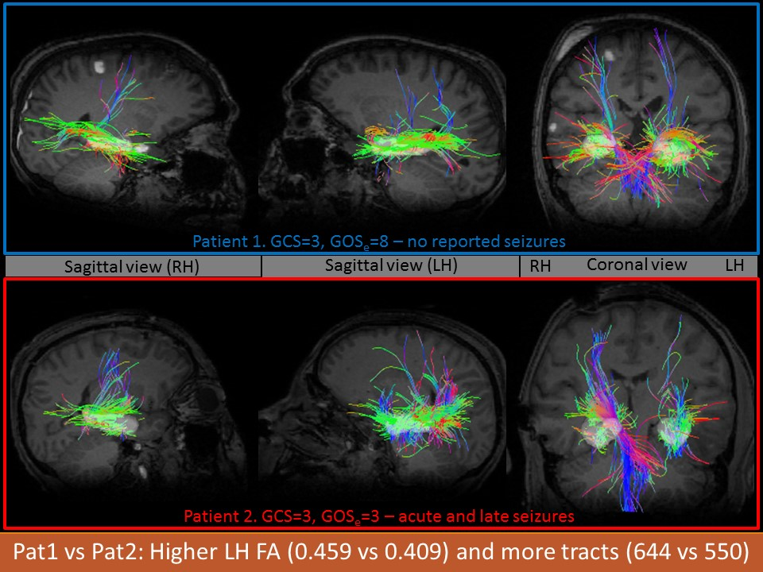

**Figure 3:** DTI structural connectomics in example cases of PTE after TBI (bottom) vs no-PTE (top) in a convenience sample of two subjects, to demonstrate feasibility of SA 2 techniques.

**3.1.7. (SA 4): Informatics and statistical analysis using hierarchical cluster (HC) analysis and Multimodel Inference Modeling (MIM) reveals that temporal lobe injury and acute seizures are biomarkers for PTE (see Informatics and Analytics Core, (IAC)18,19).** Data from our pilot study (n=46), analyzed by Multimodel Inference Modeling10, indicate that temporal lobe injury and early seizures were predictive of PTE (p < 0.003, Table 4). Integration of structural brain imaging parameters including atrophy, and morphological shape change, into the phenotypic metadata from our pilot cohort resulted in a hierarchical clustering model with a specificity of 80%.



**Figure 4:** Upregulation of rsfMRI in PTE (left) [n=4], involving thalamo-fugal connections and temporal lobe epilepsy (right), involving hippocampal-fugal connectivity22,23 [n=13 TLE vs n=11 controls].

|  |  |  |  |
| --- | --- | --- | --- |
| **Parameter (multimodel statistics)** | **p (for PTE)** | **Parameter (hierarchical cluster)** | **p (for PTE)** |
| Temporal lobe injury | 0.003 | R Thalamic chronic volume | 0.00002 |
| Temporal injury+ acute seizure | 0.007 | L Thalamic chronic volume | 0.00001 |
| Temporal injury + acute seizure + skull fracture | 0.285 | Hippocampal Left chronic volume | 0.00001 |
| Hippocampal chronic volume +GCS+ acute spikes+ early seizure+temporal injury | 0.0003 | Hippocampal Right chronic vol | 0.0007 |

**Table 4:** Predictability of phenotypical variables in a pilot study n=46, in which 57% of patients had PTE. Chronic thalamic volume, chronic hippocampal volume, temporal lobe injury plus acute seizures and acute spike count in the ICU were predictors, but not skull fracture (as proxy for injury severity) alone.

# 3.2. EXPERIMENTAL DESIGN

**3.2.1. Specific Aim 1:** **To perform prospective multicenter combined scalp and depth cEEG monitoring in moderate-severe TBI patients to determine if the occurrence of specific EEG changes, such as seizures, pHFOs, and rHFOSs, predict later PTE.**

**Hypothesis 1**: Early post-traumatic epileptic EEG activity (seizures, pHFOs, rHFOSs) indicates the presence of an epileptogenic process in patients after moderate-severe TBI.

**Deliverable 1:** Validation of a translational EEG biomarker that may be used in a future interventional trial.

**Rationale: Continuous EEG (**cEEG) is a reasonable biomarker of enhanced excitability and is well recognized to evolve from an interictal state to PTE in animal models featuring temporal lobe hemorrhagic injury. We plan to include children > age 6 given the demographics of PTE. We will longitudinally follow patients up to 2 years since 90% of PTE occurs within 2 years after TBI.

**Experimental Design and Methods:**

***Subjects:*** 300 patients with moderate-severe TBI (GCS 3-12) admitted to ICUs. The studies will be performed across experienced centers capable of high resolution monitoring including cEEG monitoring. The 13 centers include UCLA, University of Pittsburgh, MGH/Harvard, University of Maryland, Yale, Columbia, University of Cincinnati, University of Miami, Johns Hopkins, Phoenix Children’s, Royal Melbourne, and Addenbrooke Hospital in Cambridge (see Human Subjects Safety). See power calculations for justification of sample size. This group of subjects will be used for SA1-4. Patients will be enrolled over the first 4 years and followed up to 2 years after enrollment. Investigator EEG experts are Drs. Vespa, Wainwright, Abend, Staba, Gotman, Gilmore, Hirsch, Claassen, Hartings, Engel. Inclusion criteria: GCS 3-12, ages 6-100, patients with hemorrhagic contusional injuries to temporal lobes (± frontal lobes). Exclusion criteria: Patients with diffuse axonal injury in the absence of hemorrhagic contusions or skull fracture, and isolated epidural hemorrhages that improve after evacuation (see human subjects for full exclusions including pre-existing epilepsy, dementia, child abuse-TBI, etc.).

**Experimental Design and Methods:** cEEG monitoring will be done in 300 moderate-severe subjects across the participating centers. Planned longitudinal follow-up for 2 years will be done via telephonic and computer assisted means to determine incidence of PTE by 2 years. Scalp cEEG monitoring will be performed using a common 16 channel montage for all subjects, starting within 12 hours of injury for 72 hours minimum and up to 7 days after TBI in the ICU53-57. CEEG data will be uploaded to the central EEG repository for adjudication and evaluation (see IAC). CEEG 16 channel recording that uses common referential and bipolar montage and filter settings will be mandated across sites and facilitated by an established manual of operations. Preliminary monitoring and EEG reading by individual centers will be done to detect spikes and seizures using a structured format18 and the process supervised by the site Epileptologist. Validation of EEG quality and consistency across the study sites will be performed by a pre-study sample EEG validation step. The intracortical EEG (dEEG - Adtech 6 contact mini depth electrode – Ad-Tech, Racine, WI) will be placed under an IRB approved protocol in a subgroup of 100 subjects (out of total 300 enrolled) (GCS 3-8) (based on preliminary power analysis and feasibility considerations). The depth EEG probes will be placed on or into the nondominant frontal lobe in a normal appearing brain tissue region and within 1 cm of parenchymal contusion using frameless image guidance, with dual subcutaneous ground electrodes. EEG amplifier settings to enable pHFO detection including 0.1 – 500 Hz bandpass, 2 kHz sampling rates, careful quiet environment shielding and grounding will be employed. A structured protocol driven semi-automated and human supervised interrogation of the EEG will be performed to determine interictal epileptiform spikes and seizure, seizure onset, location of epileptiform onset, spike morphology11,12, spike-wave repetition rate, clustering features, field size (numbers of electrodes) and spread of electrographic seizure patterns (similar to Project 2). In addition, focal slowing and background EEG characteristics will be assessed. The majority of early post-traumatic seizures are nonconvulsive so video will not be mandated, but performed at centers in which it is standard of care. EEG will electronically be uploaded to the central EEG analysis database and a structured supervised analytic pipeline will be performed on each EEG 24 hour data set for each subject from post-injury days 1-7. EEG will be sent to the IAC for storage. Centralized EEG analysis will be performed using a team of investigators using semi-supervised algorithms and manual interpretation (Staba, Gotman, Hirsch, Abend, Wainwright, Gilmore, and Engel). Depth intracortical EEG will be used for analysis of pHFOs, rHFOSs including parameters of frequency, timing, and duration (similar to Project 2). Analysis of EEG will be done in Matlab 8.1 (Mathworks, Natick, MA and Matlab Signal Processing Toolbox), and Jean Gotman lab’s special software designed for analysis of seizures, spikes, pHFO, and rHFOSs. Drs Gotman and Staba will be supervising these EEG analyses7,29,49. Telephonic and computer-assisted follow up at pre-specified time points (3, 6, 12, 24 months) will be done to determine incidence of PTE and for cognitive comorbidities (Cogstate**®,** GOSe, GOAT, DRS – see detailed methods). An outpatient surface sleep-deprived EEG will be done at 6 months. The human subjects safety section has a detailed protocol. A confirmatory standard of care epilepsy clinic visit (including EEG, MRI, and a structured case report form) will be done for patients who screen positive for epilepsy during the 2 year follow up.

**Data Analysis and Expected Results**: The incidence rates of epileptiform activity (aka seizures, pHFOS, and rHFOSs) will be determined for each subject, including the timing, evolution, duration, total burden, and localization data. These EEG measures will be used to correlate with data obtained from SA2-SA4. Evolution of EEG patterns will be determined across the initial 7 days post injury. We expect that patients who have acute seizures, interictal spikes, pHFOs, and rHFOSs recorded will have a greater likelihood of developing PTE. Comparison of EEG results (incidence, timing, duration, localization) to the MRI results (SA2), and serum biomarkers (SA3) will be performed. The results of SA1 will be compared with EEG results in Project 1 and 2, to determine power for an eventual interventional clinical trial, since in Project 2 we anticipate antiepileptogenic drugs may also suppress epileptiform activity or the possible EEG based ‘biomarkers’ pHFOs and rHFOSs. Statistical control for multiple comparisons will be done. Clinical outcome data will be collected to establish comorbidities common to PTE including cognitive function. We expect patients with early EEG epileptiform activity will have worse comorbidities such as poorer long term cognitive function, and lower functional outcome on measurable scales (e.g. GOSe). Exploratory EEG analysis for hidden variables important to the process of epileptogenesis will be done by the Informatics and Analytics Core (IAC).

**Caveats and Alternative Approaches:** The injury subtype (temporal lobe hemorrhagic contusions) is based on our preliminary data and best aligns with our animal models, but PTE may occur with other injury types (diffuse axonal injury). We plan to incorporate an adaptive design for Project 3 to implement changes in EEG and outcomes methodology based on information and adaptations that stem from **Projects 1 and 2**. The duration of cEEG monitoring may be too short to capture critical aspects of the epileptogenic process, which could occur months after the acute insult, although preliminary rat TBI studies report pHFOs are present by 2 days after injury and rHFOSs are present within 5 days post injury. While acute EEG may be reflective of the injury biology rather than of the epileptogenic process, published studies and data from our P20 pilot group data suggest that cEEG interictal and ictal activity are not markers of injury severity. Depth EEG may not be possible in some children due to safety concerns. An alternate approach would be to use ambulatory EEG for prolonged periods of time during the subacute periods months 6-7 months after TBI, similar to what will be done in the animals in **Project 2**.

**3.2.2. Specific Aim 2: To determine if acute multimodal MRI can reveal structural and functional biomarkers (based on connectivity analyses) of local and global pathology within disconnections of hippocampal and thalamo-cortical networks that predict the development of PTE.**

**Hypothesis 2:** Acute structural/functional disconnections abnormalities within of hippocampal or thalamo-cortical networks circuits are associated with epileptogenesis after severe TBI.

**Deliverable 2:** Validation of a translational MRI biomarker or patterns of biomarkers that indicate high risk of or early development of PTE

***Rationale:***Structural and functional connectivity changes may preempt structural changes such as fiber tract disruption or atrophy, and will be more sensitive than structural MRI to microstructural changes underpinning epileptogenesis. This SA corresponds with SA 2 in Project 1 and SA2 in Project 2.

**Experimental Design and Methods:** Subjects, methods and follow-up identical to SA1. MRI (MP RAGE, DTI 64-direction, GRE, SWI) will be obtained using 3T MRI within 14 days (window 10-18 days) after TBI. A standardized Phantom will be studied at each center will be performed for quality comparison across multiple scanner types, the scanning protocols may vary across scanner types, but be adjusted to meet basic parameters. Dr. Toga and the IAC are highly experienced in this process, and will analyze variations accordingly. MRI physicists, led by Dr. Ben Ellingson at UCLA, at each site will enable compliance with imaging protocol and intersect with the IAC. In the absence moderate or deep sedation, rsfMRI will be obtained within 2 weeks of injury. Standard methodology to perform rsfMRI will be employed to ensure patient immobility, avoidance of sedation, hemodynamic instability.

**Data Analysis and Expected Results**: MRI injury location (specifically temporal lobe injury) and temporal lobe hemorrhagic lesion load (hemorrhage volume in temporal lobe) will be correlated with PTE incidence and PTE type. Morphometric/volumetric analysis will be conducted on the T1-weighted data using a shape (i.e., vertex) analysis approach39, employing FSL software together with a previously validated pipeline robust to brain pathology29. Disruption of thalamo-cortical and hippocampal structural connectivity at the global level will be assessed for each subject using connectomics30 and correlated with PTE incidence. After conventional preprocessing (e.g., slice timing correction, motion correction, smoothing, band-pass filtering) functional connectivity will be assessed through (i) seed-based analysis (making use of patient-specific segmentations of hippocampus22, 23 and thalamus as seeds), and (ii) graph theoretic analysis24,31,60. Each of these analyses incorporate additional processing steps for modeling of white matter, CSF, global mean signal46, extended motion parameters, and single-spike modeling. A broader screen of injury types (DAI vs subdural hemorrhage) will be performed in an exploratory fashion. We anticipate that those patients who develop PTE will have a higher density of hemorrhagic temporal lobe/hippocampus and its connections, greater local hippocampal atrophy (shape abnormality), greater disruption of connectivity involving thalamo-cortical and hippocampal connections, and greater total hemorrhage lesion load than the non-PTE patients22,23,24. Relation of MRI findings to data obtained in SA1 will be performed. We expect to replicate previous associations between injury and PTE1 and anticipate finding specific patterns of hippocampal and thalamo-cortical disruption in PTE patients.

**Caveats and Alternative Approaches:** The heterogeneity of traumatic lesions will result in variation of functional connectivity assessment between subjects, and hence may reduce power to detect early alterations. However, we will include only those patients with temporal and/or frontal lobe injuries (see inclusion criteria). Heterogeneity of scanners across sites will require phantom studies and coordination between Dr. Ellingson and the clinical sites’ MRI physicists. We plan on controlling for lesion size and location, and to select pathways that are free from hemorrhagic or edematous changes. We will encounter variability of interictal activity which may affect interpretation of functional data, but this provides a unique opportunity to test the dependency of functional changes upon the burden of interictal activity. Anatomical differences based on age will need to be considered in analysis. We plan contemporaneous compare with age/sex matched normal controls (n=20) at UCLA, funded separately, for comparison to TBI.

3.2.3. Specific Aim 3: To determine if candidate treatment-specific serum biomarkers informed by animal models of PTE can be validated in blood from humans after TBI.

Hypothesis 3: Specific epileptogenic pathways amenable to therapeutic interventions will generate biomarkers that can be monitored in the post-traumatic patient.

Deliverable 3: Temporal sequence of a translational soluble biomarker or biomarkers that indicate the temporal course of mechanism or mechanisms of latent epileptogenesis.

**Rationale**: There will be serum biomarkers in the animal models to indicate treatment specific pathways that are active in the epileptogenesis process. This aim is informed by **Project 1** (SA 3) and **Project 2** (SA 1 and 2) and we will be focused on validation of specific treatment-related biomarkers in the human population in order to plan a future clinical interventional trial.

**Experimental Design and Methods:** Subjects similar to SA 1, 2 and age/sex matched normal controls (n=20). Blood sampling will be obtained on a pre-specified schedule on post injury days 1, 3, 5, 15, 30, 90, 180, (± 3 days for days 30, 90, 180) after TBI. Blood will be processed, and shipped using an SOP for tissue sharing, and be banked at the EpiBioS4Rx Tissue Repository at UCLA. The samples will be analyzed, while remaining blinded to clinical status and diagnosis of PTE using a rigorous experimental design for robust and unbiased results by Dr. Denes Agoston (USU, Bethesda, MD) in batch analysis in years 4 and 5 of the study. We have powered our sample size based on p-tau and the treatment effects of sodium selenate (see power analysis), but specific treatment related biomarkers and timing of those biomarkers will be informed by results in Projects 1 and 2. We plan to assay selective human samples for these specific treatment related biomarkers discovered in Projects 1 and 2. Our anticipated panel of 15 possible biomarkers are: Injury related: NSE, neuron specific enolase; CK-BB, creatine kinase BB; S100B, S100 calcium binding protein B; GFAP, glial fibrillary acidic protein; MBP, myelin basic protein; Axonal Injury: Tau; P-tau, phosphorylated tau; NF-H, neurofilament-H; SNTF. Inflammation: IL-1B, interleukin-1 beta; IL-6, interleukin-6; IL-8, interleukin-8; TNF-a, tumor necrosis factoralpha; IFN-y, interferon gamma. Metabolic Changes: Ceruloplasmin; HIF-1a, hypoxia-inducible factor 1, alpha. In addition, testing for miRNA based on results from *Projects 1 and 2* is anticipated.

**Data Analysis and Expected Results:** The selection of treatment specific biomarkers to test in humans will be informed by results in *Projects 1 and 2*. Initially, serum will be collected at time points thought to correspond with animal timing of PTE, and frozen. Upon serum biomarker results from *Projects 1 and 2*, a focused subset of biomarkers will be assayed, according to best time window derived from animal models. The time course, sensitivity and specificity of the biomarkers for onset of PTE within 2 years will be determined. Multivariable analysis of the influence of EEG epileptiform activity (seizures, pHFOs, rHFOSs) on the appearance and time course of selected biomarkers will be assessed using results from the initial 7 days after TBI. The reliability of each the candidate treatment specific serum biomarker across time will be determined in order to plan for future interventional trials. The influence of TBI alone will be assessed by evaluating the magnitude and time course of biomarker profiles in PTE-negative subjects who have matched injury severity (GCS, pupil reactivity, age, sex).

**Caveats and Alternative Approaches:** TBI injury related biomarkers will co-vary with and overlap the biomarkers that are specific to PTE severity. We have powered for this possibility with regards to tau, which is one of the treatment specific serum biomarkers based on our preliminary treatment data in *Project 2*. The second concern is the delayed appearance of soluble biomarkers in the subacute setting, but we are collecting blood at 30, 90 and 180 days in the subacute setting to address this possibility. We will be dependent on *Projects 1 and 2* to inform the best biomarkers, some of which may not be soluble but rather tissue dependent. We will have a small collection of brain tissue from mortality cases and surgical debridement, but anticipate low power due to insufficient number of cases with concurrent PTE and available brain tissue. We have considered CSF and microdialysis tissue sources for biomarkers, and anticipate having a small cohort of this tissue type to use for exploratory analyses. However, we are searching for blood biomarkers since that will translate best from animal experiments in *Projects 1 and 2*, and also be applicable in future clinical interventional studies.

**3.2.4. Specific Aim 4:** To establish a highly qualified ICU EEG TBI clinical trials network that would enable planning for a personalized medicine human intervention trial.

**Hypothesis 4:** Prospective implementation of high resolution advanced EEG methods among our TBI-ICU-EEG-study sites will enable the selection of an enriched population of patients based on EEG and MRI features for at high risk for a future interventional trial.

**Deliverable 4:** A highly trained ICU EEG-TBI clinical trials network that includes TRACK TBI, ADAPT, and CENTER TBI with DSMB in place and meta-data biorepository, capable of implementing a future clinical trial using a personalized medicine approach designed with input and recommendations from the Public Engagement Core.

**Rationale**: Previous studies on PTE have not used personalized medicine to enrich the subject pool, nor used EEG monitoring to target a treatment group or a treatment window. Our approach will be to create a highly qualified network of clinical trial sites, and determine the optimization methods to develop a large number of sites capable of conducting a pivotal interventional trial informed by best evidence.

**Experimental Design and Methods:**During the conduct of SA1-3, we will be establishing training and dissemination methods to ensure translation of complex and high quality clinical trial centers. We will focus on dissemination of a manual of operations for the ideal methods for ICU EEG, Depth EEG, and recordings of pHFOs among centers that would be poised for an intervention trial. We will create implementation and quality assurance mechanisms to ensure high quality EEG recording at each site, including accurate EEG interpretation of pHFOs, rHFOSs, and seizures. We will use an adaptive design informed by *Projects 1 and 2*, the DSMB and the Public Engagement Core to prepare the centers and obtain strategic data for the purposes of planning a future clinical interventional trial. Feasibility information including accuracy of EEG detection, and false positives will be assessed in order to plan a future interventional trial. The IAC will use these data and that the existing databases from CENTER-TBI, ADAPT and TRACK TBI in order to determine the generalizability of our findings in this study to the larger cohort of potential TBI study subjects (see letters of collaboration). Data mining for clinical endophenotypes, specifically injury location, will be done using principal components analysis, hierarchical cluster analysis, and multimodel analysis18,19. Dr. Toga is a PI of TRACK TBI in charge of image analysis and database, and Dr. Vespa is a Co-PI of the TRACK TBI ICU Cohort Studies working group. TRACK TBI will have similar MRI methods and data sets that will enable testing for generalizability of our results to a broader TBI population. Meta-data from TRACK, CENTER, and ADAPT studies will enable feasibility planning for patient enrollment, follow-up and tracking for a future interventional study. We have agreement by all three large scale TBI studies to share data in this way.

**Data Analysis and Expected results:** Implementation science analysis of the process of developing the centers of excellence will be performed. Adaptive design will be needed to implement protocol changes based on results from *Projects 1 and 2*. Analysis of factors which enhance reliability of expert EEG and depth EEG will be performed. Big data approaches will be used to create forecasts of projected enrollment of targeted populations for an interventional trial. Initial target criteria are based on our hypothesis that temporal lobe hemorrhagic injury, early seizures, early pHFOs and rHFOSs will indicate the high risk population. The DSMB (Drs. French, Perucca, Jette, Bleck, Kwan, and Twyman – see Human Subjects Safety) and Public Engagement Core will intercalate the results of *Project 2* into our human data set to determine optimum patient selection, timing of intervention, and specific biomarker monitoring in order to design a future interventional clinical trial.

**Caveats and Alternative Approaches:** An adaptive design to enhance data collection and site preparation, informed by results from animal *Projects 1 and 2* will be incorporated. Results from *Projects 1 and 2* could indicate a chronic intervention window, and hence require adjustment of the follow up protocol. We plan to remain flexible to perform later and more detailed follow up including additional biomarker time points in the chronic setting.

## 3.3. DETAILED METHODS

**Subject Enrollment and Planned Longitudinal Follow up**: (see human subjects safety) Patients with moderate-severe TBI (GCS 3-12) will be enrolled. Inclusion criteria (highlights): GCS 3-12, closed head injury, ages 6-100, visible structural hemorrhagic contusional damage on CT in temporal lobe ± frontal lobes, able to get MRI. Exclusion criteria (highlights): preexisting epilepsy, penetrating injury, prior TBI, pregnancy, protected populations, existing neurodegenerative or psychiatric disease, prior stroke, cognitive disability. Patients will be enrolled within 24 hours of TBI, studies commenced using a SOP for data collection, data entry, imaging, and cEEG. Normal controls (n=20) for MRI and blood sampling already exist as part of the UCLA Brain Injury Cohort studies. Follow up at 1 month, 3 months, 6 months, 1 year and 2 years will be done via telephonic and computer assisted methods using the Ottman Epilepsy questionnaire, Glasgow Outcome Score Extended (GOSe), Galveston Orientation and Amnesia Test (GOAT), Disability Rating Scale (DRS), Quality of Life Assessment (QOLIE-31 or QOLIE-31 P, based on age), and Cogstate**®** computerized cognitive testing.

**Common Data Elements Collection and Data Sharing:** A structured data entry form for TBI and Epilepsy Common Data Elements will be completed on-line using Database hosted at the IAC. All data is covered by a Certificate of Confidentiality. Data sharing with FITBIR and NIH is planned for all data for open access.

**Blood and Tissue Sample Collection:**A standardized protocol for blood and CSF fluid collection is defined for the study. Blood draws, 5 cc per draw: Schedule will be day 1, 3, 5, 16, 30, 90, 180 after TBI. Blood is then processed before freezing at negative 80**°**C: 5 ml whole blood is processed for serum isolation within 3 hours of collection by centrifugation at 3,000 r.p.m. for 5 min at room temperature, followed by a 5 min centrifugation at 12,000 xg at 4 °C20. Pathological tissue from surgery: day 1. All samples are bar coded and shipped to the EpiBioS4Rx biospecimen repository at the UCLA.

**ICU cEEG**: A formal written SOP for cEEG will be used. A 16 channel EEG using a referential and bitemporal montage will be done at each center and data will be permanently recorded and stored54,56,57. Depth EEG using will be done as below. An iterative process of EEG and depth EEG optimization will be done. Validation of artifact free cEEG, technical quality and conformity to EEG protocol will be done for the initial 2 subjects at each center by the EEG review team (see below). CEEG monitoring for a minimum of 72 hours up to 1 week will be recorded. EEG will be de-identified, assigned a study number, and uploaded to LONI for planned analysis. Local electroencephalographers review of EEG on a daily basis will be performed to rule out seizures. Formal scoring of EEG for interictal spikes and seizures will be done by the EEG review team (Drs. Vespa, Abend, Hirsch, Wainwright, Gilmore, Engel). Automated algorithm analysis of EEG for spike morphology, spike counts, etc. will be semi supervised using Persyst, Matlab, and Gotman software. Supervision of automated and semi-supervised EEG analysis will be done in consultation with Drs. Gotman and Staba.

**Depth EEG HFO detection**: Analysis as previously described7,8,9,29,49, 64. Semi-automated algorithms to detect epileptiform EEG spikes, rHFOSs, and HFOs have high sensitivity, but only moderate specificity, and therefore our approach includes manual review to remove putative events contaminated with movement- and electronic-related noise. Analysis of spontaneous dEEG events will be carried out using Matlab (Mathworks, Inc. Natick, MA). Detection will compare the energy of the signal to an energy threshold64 using finite impulse response bandpass filters (rolloff -33dB/octave) to restrict energy for EEG spikes (1-30Hz), rHFOSs (8-20Hz), and HFOs (100-600Hz). The energy threshold will be set at 5 SD above the mean bandpass signal calculated over entire length of data epoch, but for rHFOSs and HFOs, the energy threshold will be applied to the rectified RMS (rHFOSs: 700 ms sliding window, HFOs: 10 ms) of the respective bandpass filtered signals. In addition, we will consider each rHFOS and HFO event as having a minimum duration of 600 and 6 ms and inter-event interval of 100 and 10 ms respectively, and events consisting of 6 or more peaks greater than 3 SD from mean bandpass signal. For each event we will review the unfiltered and bandpass filtered signals, as well as Morlet wavelet-based time-frequency spectrogram to inspect and measure spectral power and duration of EEG events.

**Epilepsy Standard of care clinic visits and Epilepsy Adjudication Methods**: Subjects that have screened positive within 2 years for possible seizures will undergo a structured confirmatory standard-of-care epilepsy clinic evaluation, EEG and MRI within 1 month of screening positive at the local center by a participating epileptologist. A volumetric brain will be performed as standard of care and sent to LONI for anatomic analysis (similar to SA 2). A structured case-report form will be completed for research purposes at this visit. An adjudication committee (Drs. Hirsch, Abend, Wainwright, Gilmore, Engel) will review each case report form to confirm the diagnosis of PTE, document seizure type, EEG results, and response to antiepileptic drugs, and complications. The adjudication committee will be blinded to ICU EEG, MRI, and blood biomarker results in order to perform a rigorous and unbiased assessment of the data.

**MRI Imaging Methods*:*** A standardized MRI imaging protocol exists for UCLA Brain Injury Center and will be adapted for this study37,66. 1.5 T or 3 T MRI for structural imaging, and 3T rs fMRI will be performed for each subject. Dr. Ellingson, the UCLA MRI physicist, and the IAC will validate quality and consistency across all scanners . Phantom studies: BIRN fMRI (monthly) and NIST DTI phantom will be performed at each site during years 1 and 2 to confirm quality and accuracy.

|  |  |  |  |  |  |  |  |  |  |  |  |
| --- | --- | --- | --- | --- | --- | --- | --- | --- | --- | --- | --- |
|  |  | | Parameter | | | | | | | | |
| Sequence | | TR  [ms] | | TE  [ms] | FA [deg] | ETL | Directions | thickness  [mm] | FOV [%] | acquisition type | matrix |
| T1 | | 1900 | | 4 | 9 | 1 | N/A | 1.0 | 100 | 3D | 256 x 256 |
| TSE | | 3330 | | 89 | 120 | 18 | N/A | 1.0 | 100 | 3D | 256 x 256 |
| FLAIR | | 8000 | | 70 | 130 | 16 | N/A | 1.0 | 100 | 3D | 256 x 256 |
| GRE | | 1500 | | 7 | 20 | 1 | N/A | 1.0 | 100 | 3D | 256 x 256 |
| SWI | | 27 | | 20 | 15 | 1 | N/A | 1.0 | 100 | 3D | 256 x 256 |
| DTI | | 8000 | | 95 | 90 | 1 | 64 | 1.0 | 100 | 3D | 256 x 256 |
| DWI | | 4000 | | 80 | 90 | 1 | N/A | 1.0 | 100 | 3D | 256 x 256 |
| Bold | | 3000 | | 30 | 78 | 64 | N/A | 3.0 | 100 | 2D | 64x 64 |
|  |  |  |  |  |  |  |  |  |  |  |  |

Scanner validation and quality assurance including image quality and image acquisition will be performed by the Informatics Core (LONI), using an approved SOP for phantom scanner validation at each center, and inter-scanner comparisons.

**Statistical Analysis**: (See IAC for full details of statistical methods including hierarchical cluster analysis, multimodel inference modeling10, and overarching statistical methods). Statistical analyses on primary data in *Project 3* will use R (ver 3.2.3) (R Core Development Team, 2016). Functional MRI and shape analysis will be performed using FSL and Matlab39. DTI data will be analyzed by the IAC.

**Power Analysis:** In this study, we assessed the number of human subjects necessary to answer several aims, and hence the numbers vary across aims14. For SA1, the number to determine if early seizures (recorded on depth or surface) predict late PTE was based on a 50% incidence of early seizures and 50% incidence of PTE (in this highly selected group) was n=144. Assuming a 30% attrition rate, initial n=187. For HFO, we have only animal data to consider for power estimates, with 60% of animals having HFOs early after TBI. We anticipate incomplete overlap between early seizures and HFOs, hence an additional 100 subjects are being added empirically for depth EEG pHFO and rHFOSs studies. For SA2, we powered the MRI studies based on our existing work regarding temporal lobe injury being prevalent in the PTE group (74% in PTE vs 35% in non-PTE; effect size h=0.805, total n=120, or initial n before attrition = 172). For SA3, we used results from animal studies of the effect of PTE on tau (Liu et al (2016) and the effects of sodium selenate to mitigate seizures and tau expression. We also used existing human studies of serum tau levels after TBI to model the expected increase in serum tau that occurs due to trauma complicated by seizures. We powered the study in order to demonstrate between group differences in those patients with severe TBI plus seizures vs those with severe TBI alone during the initial week after TBI. Based on published values for serum tau (ranging from 10 pg/ml (SD 15)48 in mild TBI to 436 pg/ml (SD 472)33, the number of subjects needed was n= 108. With 30% attrition, n= 144. We are planning enrollment of 300 subjects since we anticipate some degree of non-overlapping results in SA 1-3.

**3.4. TIMELINE and MILESTONES**

**Timeline of entire study and integration with *Projects 1 and 2*:** In Figure 5, we outline the timeline and milestones for *Project 3*.

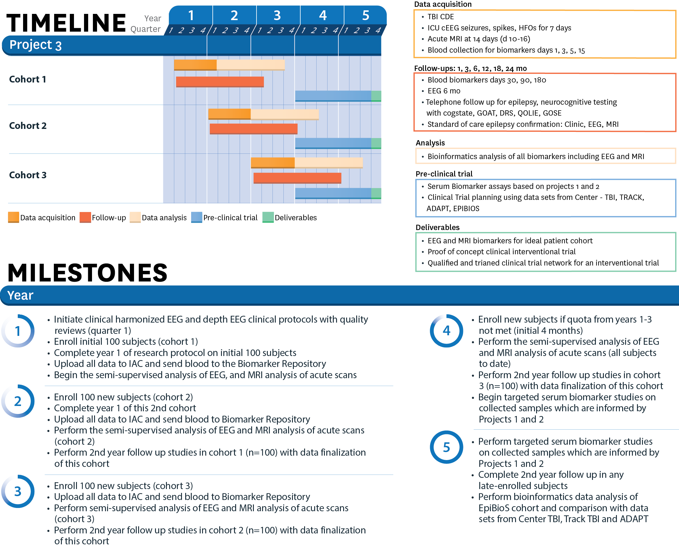

**Figure 5:** Timeline of studies in Project 3.

# 3.5. integration with other projects and translation

In Figure 6, we outline the translational aspects of the entire CWOW. The animal projects will serve to identify and validate antiepileptogenic treatments that can be readied for an interventional trial.

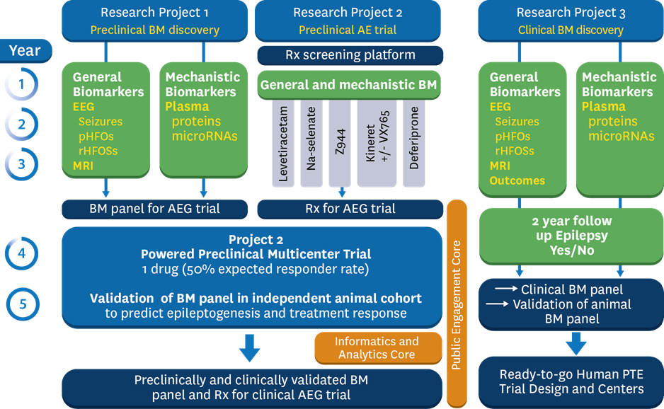

**Figure 6:** Alignment and synergistic integration of the 2 animal and 1 clinical projects. Abbreviations: BM: biomarker, AEG: antiepileptogenesis, pHFO: pathological High Frequency Oscillations, rHFOSs: repetitive HFOs.